***SUBMISSION TO ________________***

**Title:** Measles outbreaks in conflict-affected northern Syria: Results from an ongoing outbreak surveillance program

**Authors:** Sammy Mehtar*, Naser AlMhawish*, Mohamed Redwan, , Arthur Reingold, Rohini J. Haar

*Author Affiliations*

|  |  |  |  |  |
| --- | --- | --- | --- | --- |
| Name | Degrees | Title | Organization | Email |
|  |  |  |  |  |
| Sammy Mehtar  *corresponding author | BA, MS in December | Medical Student | UC Berkeley – UCSF Joint Medical Program | smehtar@berkeley.edu |
| Naser AlMhawish | MD | Surveillance Coordinator | ACU | Naser.m@acu-sy.org |
| Ahmad Alyousef | MD |  | ACU | a.alyousef@acu-sy.org |
| Mohamed Redwan | MD | Response Coordinator | ACU | Muhannad.r@acu-sy.org |
| Rohini J. Haar | MD MPH | Lecturer | University of California, Berkeley. School of Public Health, Division of Epidemiology, Berkeley, CA | rohinihaar@berkeley.edu |
| Arthur Reingold | MD | Professor | University of California, Berkeley. School of Public Health | reingold@berkeley.edu |

**Keywords:**

Syria, conflict, war, measles, epidemic, infectious diseases, surveillance, vaccine, vaccine-preventable disease

Paper 2 Draft #4

1. **Abstract**

*Background*

The Syrian conflict has dramatically changed the public health landscape of Syria since its onset in March of 2011. Indiscriminate targeting of healthcare facilities, transports, medical personnel, and patients throughout the conflict have had tremendous impact on Syria’s healthcare capacity and priorities. Coupled with depleted resources and increased security risks, many routine services, including vaccinations, have been disrupted across several regions in Syria. The Assistance Coordination Unit (ACU) has established a robust active surveillance system, known as the Early Warning Alert and Response Network (EWARN), for infectious disease syndromes in opposition-held territories. There is a critical need to better understand infectious diseases in conflict-affected communities and the ACU database provides a unique opportunity to do so in Syria. This study focuses on trends of measles incidence in northern Syria, and analyzes on two consecutive epidemics in 2017 and 2018. Measles was chosen because…

*Methods*

The ACU relies on modified World Health Organization case definitions for the 13 syndromes covered by EWARN, including suspected measles, acute flaccid paralysis, and diarrheal diseases, amongst others. We conducted a retrospective ecological time-series analysis on measles incidence using EWARN data on clinical case counts between January 2015 – June 2019. We compared regional and temporal differences to assess for significant differences across between geographic areas or across time.

*Results*

There were 27,707 clinical cases of measles reported over the study period. Children <5 years were at a greater risk than the rest of the population (Wilcoxon signed-rank test, p-value < 0.001), and there was no significant difference between males and females across all ages (Wilcoxon signed-rank test, p-value = 0.1431); however, there was a significant difference between males ≥5 years and females ≥5 years, with more clinical cases of females (Wilcoxon signed-rank test, p-value = 0.02637). There were significant differences in measles incidence across years (Kruskall-Wallis test, p-value < 0.001), as well as across different geographic regions (Kruskall-Wallis test, p-value < 0.001). There were major measles outbreaks in 2017 and 2018, primarily in the eastern governorates of Ar-Raqqa and Deir-ez-Zor.

*Conclusions*

Outbreaks of measles in 2017 and 2019 were the largest since Syria had eliminated the disease in 1999. The regions most affected by the 2017 and 2018 measles outbreaks were regions heavily targeted in the conflict and *Daesh* strongholds until 2017. There was limited access to aid organizations or government services and vaccination rates decreased during that time. Furthermore, 2017 was the first year in which all children <5 years were born during the conflict, most never having had access to routine care. Further studies relating the severity of the conflict or attacks on healthcare facilities should be conducted to better assess the relationship between conflict and vaccine preventable diseases.

1. **Introduction/Background**

Armed conflict is a major source of death and injury worldwide.1–4 Some of the effects of armed conflict on public health are direct and self-evident, such as battlefield wounds or traumatic injuries. Indirect consequences are more tortuous, and includes disrupted health systems, displaced populations and health workforce, the breakdown of infrastructure, and heightened risk of disease transmission, which may impact a significantly larger group of inhabitants over years or decades.1,2,4,5 Many survivors of a conflict may be physically or mentally scarred for life, and the disruption of critical services and supplies, such as healthcare, education, energy, water, and food, can leave behind long-term impacts affecting future generations.1,2

Since its onset in 2011, the Syrian conflict has evolved into a complex humanitarian disaster, resulting in over 5.6 million refugees, 6.6 million internally displaced persons, and an untold number of casualties out of an estimated pre-war population of 23 million people.6–8 During this period, Syria has suffered significant health and healthcare challenges, including the reemergence of vaccine preventable diseases, such as polio and measles, targeted attacks on healthcare facilities, workers, patients, and supplies, and the disruption of public health services in opposition-held territories.4,9–17 These challenges, coupled with massive inflation, limited supplies, energy shortages, lack of safe transportation, the loss of vital infrastructure such as water and sanitation, and the flight of over half of Syria’s physicians have led to dramatic changes in the public health landscape of Syria, including the epidemiology of infectious diseases.18–23

The conflict has also disrupted the public health surveillance capacity of Syria, primarily in regions that fell outside of government control, since the Syrian Ministry of Health could no longer operate in those territories.24,25 Initially, this contributed to diminished preventative services and uncoordinated or delayed response efforts in those areas.11,17,26 The Wild Polio Virus Type-1 (WPV-1) outbreak in 2013 was a motivating cause for the two separate surveillance efforts that have since been established, one covering territories controlled by the Syrian government, operated by the Syrian Ministry of Health, and one for opposition-held territories, operated by the non-governmental organization, the Assistance Coordination Unit (ACU).17,25,27–29 The ACU had established an operational acute flaccid paralysis (AFP) surveillance system for polio by the end of 2013; however, ACU’s methods and coverage of multiple infectious disease syndromes did not fully develop until the start of 2015. Both surveillance systems are modeled after and supported by the WHO’s Emergency Surveillance and Response System (EWARS).25,28,30 The surveillance system of the Syrian MOH shares the same name, EWARS, while the surveillance system operated by the ACU is known as the Early Warning Alert and Response Network (EWARN). ACU publishes weekly and annual epidemiologic reports to the WHO, the Gaziantep Health Cluster, and in their online newsletter but this data has not been collated and analyzed publicly until now.

Several studies have sought to describe the immediate and local health impacts of the conflict. The impacts of the conflict on health and healthcare has resulted in greater casualties than the conflict itself.31 Access to medication and specialty care for non-infectious diseases has diminished, affecting hundreds of thousands of patients suffering from a variety of illnesses, such as diabetes mellitus or cancer.3 In some regions, critical care centers are staffed by undertrained physicians and lack proper equipment or ability to follow evidence-based protocols.3,23 A case study on Aleppo of the effects of the conflict on health and healthcare found that in 2015 there was about one physician for every 7,000 people, compared to one for every 800 prior to the conflict.16 Sanctions and the collapse of the exchange rate has resulted in skyrocketing costs for commodities, including health services and medications.14 The conflict has reintroduced many previously controlled infectious diseases, not only into Syria but into neighboring countries as well.11 The main burdens of disease in children <5 years has been infectious disease and malnutrition.32

However, little is known about the specifics of how the epidemiology of vaccine preventable diseases have been shaped over the course of the war, especially in territories beyond the reach of the Syrian Ministry of the Heath. There are particular questions on how health disruptions varied over time and region to impact health. This study hopes to contribute to our understanding of the impacts of the Syrian conflict and the relationships between health and conflict more broadly by using a longitudinal surveillance dataset collected in the midst of the Syrian conflict to study the epidemiology of measles, given its relationship to conflict and displacement.33

1. **Methods**

We conducted a retrospective analysis of ecological infectious disease surveillance data collected primarily in northern Syria between January 1st, 2015 and July 31st, 2019 by the Early Warning Alert and Response Network (EWARN) operated by the Assistance Coordination Unit (ACU).

*Surveillance System*

Alongside its other projects, the ACU maintains EWARN, established in 2013 and modeled after the World Health Organization’s (WHO) Early Warning and Response System (EWARS).28 EWARN is an active surveillance program, in which surveillance data is periodically requested from health providers, and was designed for rapid and cost-effective implementation in humanitarian or conflict settings to improve disease outbreak detection.30,34,35

EWARN covers 13 diseases and conditions, selected for their potential to cause epidemics, their association with high morbidity and mortality, and the potential for intervention in Syria.30 EWARN’s objective is the early detection of outbreaks and to communicate epidemiological data with partner organizations.

EWARN’s follows a zero-reporting protocol, which distinguishes between missing cases and zero cases; if cases in a district in a given week are not reported due to some constraint or lack of coverage, it is reported as missing, distinct from districts that report zero cases for a given week. Note that cases are not laboratory confirmed, but rather meet the defined clinical and epidemiologic protocols discussed in the methods section.

*Administrative Divisions*

Syria is administratively divided into 14 governorates, (*muhafazat)*, which are further divided into 65 districts (*manatiq)*, and 281 subdistricts (*nawahi)*. These administrative divisions have remained in place throughout the conflict, and are used by the Syrian government, the UN, the WHO, foreign governments, and the various NGOs operating in Syria. While the ACU shared data at the subdistrict level, limitations in population estimates for 2015-2016 and ongoing security concerns compelled us to restrict this study to the district level.

*Total Population*

Population estimates for Syria between 2015 and 2019 were obtained from the ACU but originally were collected and distributed by the United Nations Office for the Coordination of Humanitarian Affairs (UNOCHA).36 These population estimates are conducted annually and distributed to UN agencies and other governmental and non-governmental organizations (NGOs) working on health-related concerns in Syria.

2015-2016 population estimates were conducted at the district-level, while 2017-2019 were conducted at the subdistrict-level, limiting our population-dependent statistics to the district-level despite subdistrict-level granularity of the surveillance data. Demographic characteristics, including age and sex, are not a part of the population data, limiting our ability to estimate attack rates for subsets of the population.

Population was estimated annually by UNOCHA, while EWARN surveillance data was collected on a weekly basis, leading to distortions in incidence. Changes in population appeared as discrete jumps at the beginning of each year. This was addressed by linearly imputing weekly population estimates to minimize artifacts in estimates of incidence and better represent change in population over time.

*Study Population*

The study population consisted of every outpatient presenting at a healthcare facility within the EWARN coverage area that met the conditions for one of the 13 syndromic case definitions (see Table 1). Cases were de-identified and aggregated by sex (male, female), age (≤5 years old, > 5 years old), and subdistrict into weekly case-counts for each syndrome by the ACU.

*State vs. Non-State Held Territories*

The Syrian conflict has developed into a complex, international conflict with many actors, factions and proxies, each with their own competing interests. For the purposes of this paper, however, the complex geopolitical landscape will be simplified into two categories: territories that are under the control of the Syrian government, which will be referred to as state held territories, and those that the Syrian government is not in control over, which will be referred to as non-state held territories.

This is a dynamic landscape that has not remained constant for any extended period throughout the conflict, and as the geopolitical realities shift, so, too, do the coverage regions of EWARN. The governorates of Damascus, Rural Damascus, and Lattakia, and the districts of *As-Safira*, *Tadmor*, and *Al-Fiq* are not included because they have remained outside of EWARN’s coverage region for most, if not all, of the conflict. The other 11 governorates and constituent districts have been included, despite changes in coverage throughout the conflict. Districts that fall out of coverage are reported as having missing case reports.

*Case Classifications*

According to the WHO, “countries are advised to use the clinical classification scheme until their programmes meet the following two criteria: low levels of measles incidence or access to a proficient measles laboratory;” after achieving these targets, the WHO recommends “a laboratory classification scheme should be used by countries in the low incidence or elimination phase.”37

ACU provides guidelines for EWARN case classifications that are updated annually.30 Cases that meet the definition for one of EWARN’s syndromes are classified as Syndromic Cases (*See Appendix for Table of Syndromic Case Classification).* A patient-visit to one of the healthcare facilities within the EWARN network is documented as a consultation, and each region reports the total number of consultations along with the syndromic surveillance data each week.

Table 1: Syndromic Diseases covered by EWARN

|  |  |  |
| --- | --- | --- |
| Abbreviation | Clinical Syndrome | Suspected Disease |
| ABD | Acute Bloody Diarrhea | Shigellosis |
| AWD | Acute Watery Diarrhea | Cholera |
| OAD | Other Acute Diarrhea |  |
| AJS | Acute Jaundice Syndrome | Hepatitis A & E |
| ILI | Influenza-Like Illness | Influenza |
| SARI | Severe Acute Respiratory Illness | Avian Influenza A (H7N9), MERS-CoV, other |
| AFP | Acute Flaccid Paralysis | Poliomyelitis |
| MEA | Suspected Measles | Measles |
| MEN | Suspected Meningitis | Bacterial Meningitis |
| STF | Suspected Typhoid Fever | Typhoid |
| LEISH | Leishmaniasis | Cutaneous Leishmaniasis |
| UCE | Unusual Cluster of Health Events | N/A |
| UCD or UXD | Unusual Cluster of Deaths | N/A |

*Measles*

Measles one of the most highly contagious human diseases known. It results from an infection with the measles virus (MV) and is transmitted via the respiratory system.38 MV is an enveloped, non-segmented, single-stranded, negative-sense RNA virus. The incubation period is 10-14 days. Symptoms include fever, cough, coryza, and conjunctivitis, with pathognomonic Kolpik Spots followed by a characteristic erythematous, maculopapular rash starting on the face and progressing to full-body involvement.39 Pneumonia accounts for the majority of measles-associated morbidity and mortality, but complications can affect any organ system.38 Measles is a vaccine-preventable disease (VPD).38,39

The global burden of measles was estimated to be 6.7 million cases in 2017, with 173,330 cases reported to the WHO. In 2018, estimates are that that number more than doubled to 353,236 cases reported to the WHO (final numbers set to be released in November 2019).40,41

Between 2015-2018, the ACU relied on the World Health Organization (WHO) definition of measles30,37,40. Suspected cases are those in which the patient presents with a fever and non-vesicular maculopapular rash, or in whom a healthcare worker suspects measles. Clinically compatible cases are those in which patients present with fever and maculopapular (non-vesicular) rash and at least one of cough, coryza or conjunctivitis.40

Measles was chosen for closer investigation because, due to its high infectivity, it is highly sensitive to vaccination rates and thus can serve as a good indicator of drops in vaccination rates within a relatively short time period. Many public health consequences of conflict may not become fully apparent for years to come, while Syria has already experienced multiple measles epidemics during the course of the war. We also have some idea about the state of measles epidemiology in Syria prior to the conflict, since Syria had eliminated autochthonous cases of measles since 1999. Lastly, it is well-measured by the EWARN system: most clinically suspected cases that are further tested receive laboratory confirmation.

*Data Collection*

EWARN’s data management is hierarchically structured by geographic levels. Individual health facilities are at the “field level”, and data is actively collected from each center by Field Level Officers (FLOs). Each FLO is responsible for collecting weekly zero-reports in a specified format from the health facilities within their designated area. These reports are then submitted to District Level Officers (DLOs), who collect the reports from each community and subdistrict within their designated district and then submit a weekly report to Central Level Officers (CLOs) at ACU’s headquarters in Gaziantep, Turkey. The CLOs then document these facility reports and publish weekly aggregated case-counts at the district and governorate level.

The quality of the data is routinely assessed by calculating the completeness and timeliness of reporting for each district. EWARN enforces zero-reporting for the health facilities in its network to distinguish between non-reporting and true lack of cases, a crucial element for surveillance in a conflict setting where facilities or entire districts may be unable to report due to difficult circumstances.

Data was collected from January 1st, 2015 to July 31st, 2019 through active surveillance of healthcare facilities within EWARN. Population-level information was collected, including 1) locale of each case at the subdistrict-level, 2) sex of each case, 3) whether the case was younger than or older than five years of age.

*Data Management and Analysis*

Data was documented and shared by the organization using Microsoft Excel. The results were analyzed and visualized using R and ArcGIS. Descriptive analyses of surveillance data used characteristics of the study population, which included binary variables for age, sex, and geographic district. The χ2 test was used, with a P-value of <0.05 chosen as the threshold for significance. All data was maintained in secured encrypted password protected machines.

*Ethical Approval*

This study was reviewed and exempted by the University of California, Berkeley Institutional Review Board.

1. **Results**

*Surveillance System*

A total of 40,577,249 consultations were conducted by facilities within the EWARN January 2015 and June 2019. Of those, 7,925,079 (19.53%) were cases that meet the criteria for one of the EWARN syndromes, while the remaining 80.47% were cases whose clinic presentation did not meet the definitions of any of the syndromes documented by EWARN. Table 1 illustrates the population characteristics of the cases. Population estimates did not capture characteristics of the entire population, thus incidence for each syndrome could not be stratified by age and sex.

|  |  |  |  |
| --- | --- | --- | --- |
| *Syndromic Cases* | **Female** | **Male** | *Total* |
| **<5 years old** | 1,591,412 (20.08%) | 1,616,073 (20.39%) | *3,207,486 (40.47%)* |
| **≥5 years old** | 2,446,487 (30.87%) | 2,271,107 (28.66%) | *4,717,593 (59.53%)* |
| *Total* | *4,037,899 (50.95%)* | *3,887,180 (49.05%)* | *7,925,079 (100%)* |

Figure 2

|  |  |  |  |
| --- | --- | --- | --- |
| **Year** | **Syndromic Consultations** | **Non-Syndromic Consultations** | **Total Consultations** |
| 2015 | 942,398 | 5,523,324 | 6,465,722 |
| 2016 | 1,839,233 | 6,457,191 | 8,296,424 |
| 2017 | 2,081,142 | 8,061,980 | 10,143,122 |
| 2018 | 2,110,946 | 8,739,335 | 10,850,281 |
| 2019 | 951,360 | 3,870,340 | 4,821,700 |
| **Total** | **7,925,079** *(19.53%)* | **32,652,170**  *(80.47%)* | **40,577,249**  *(100%)* |

Figure

Figure 3

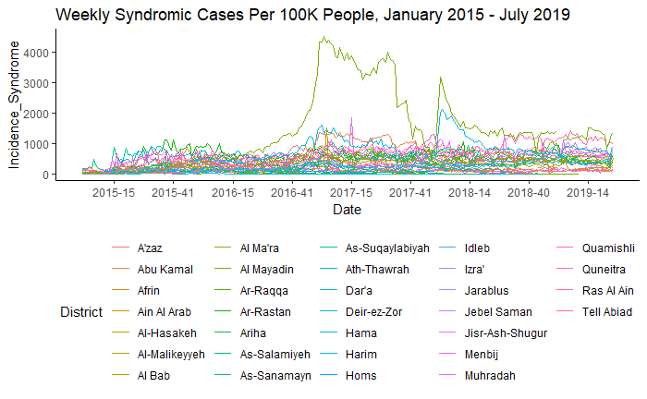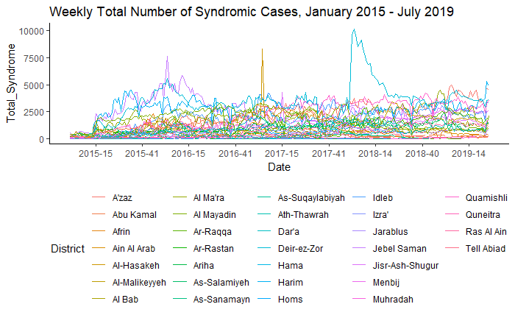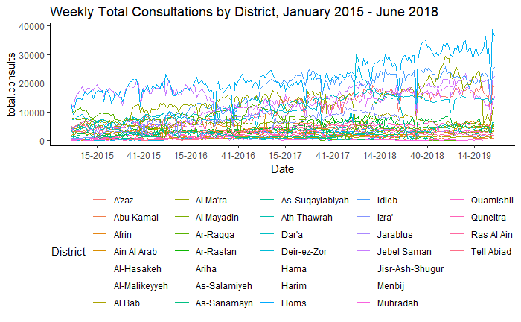

Figure 1 illustrates the total number of syndromic cases captured each week by EWARN between January 1st 2015 and July 31st 2019. Figure 2 shows the total incidence of all syndromic cases in that same period. Figure 3 shows the total number of consultations that were not part of the syndromic surveillance.

*Measles*

Cases of measles were reported in every governorate except for Homs. The governorates of *Ar-Raqqa* and *Deir-ez-Zor* had the highest number of cases, followed by *Idlib* and *Aleppo*. There was variability in the incidence of measles within governorates as well (is this statistically significant?)The greatest incidence was in *Al-Mayadin* and *Abu Kamal* Districts in the 2017 outbreak, and *Ar-Raqqa*, *Al-Mayadin*, and *Deir-ez-Zor* had the highest incidence in the 2018 outbreak.(see Figure 1)

Children <5 years of age were at a greater risk than the rest of the population, accounting for 60.87% of reported cases. While there was no significant difference between male children and female children (51.39% vs. 48.61% of <5 cases, Wilcoxon Rank Sum Test p-value = 0.726), there was a statistically significant difference between sexes in cases ≥5 years (54.47% vs. 45.43% of ≥5 cases, Wilcoxon Rank Sum Test p-value < 0.001) with females at a greater risk than males.

Figure 1: Measles incidence, geographically and temporally

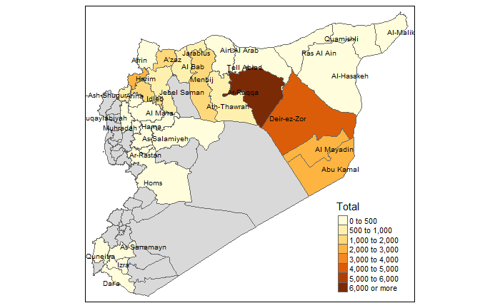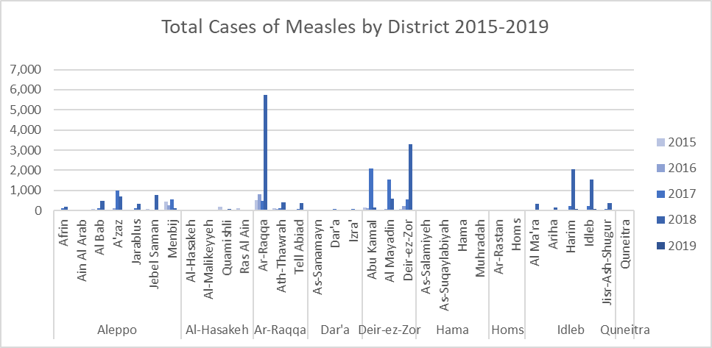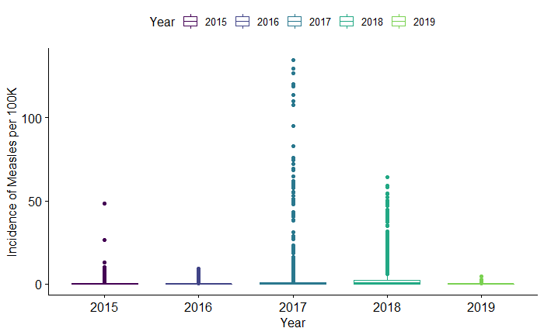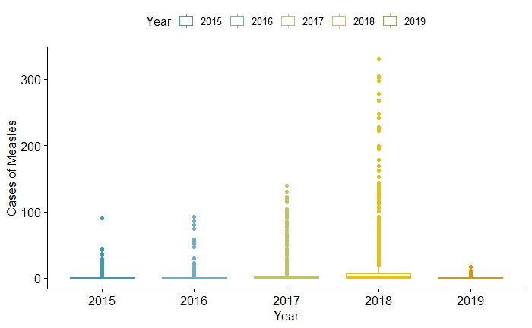

*Outbreak Evaluation*

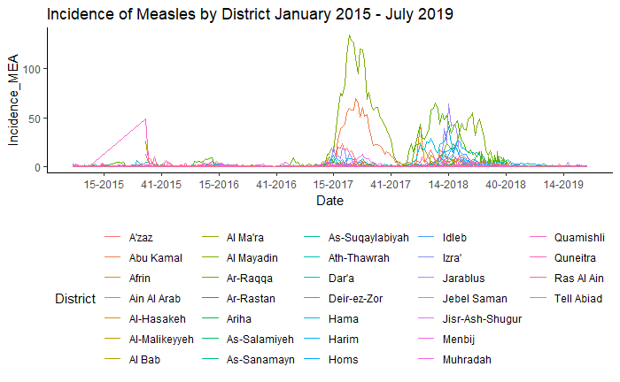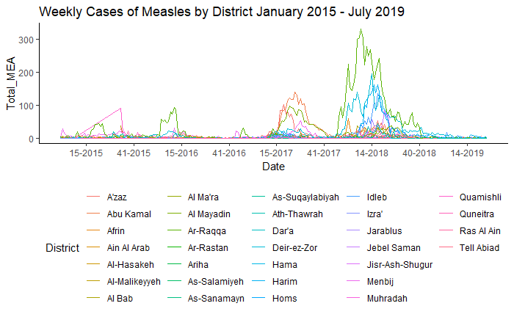

The largest measles outbreaks of 2017 were concentrated in *Abu Kamal* and *Al-Mayadin* Districts in the *Deir-ez-Zor* governorate, while the largest outbreaks in 2018 were concentrated in *Al-Mayadin* and *Deir-ez-Zor* districts in *Deir-ez-Zor* governorate and *Ar-Raqqa* district of *Ar-Raqqa* Governorate. In 2017 incidence peaked towards the end of June and beginning of July, while in 2018 incidence peaked around end of March. The 2018 outbreak had a more gradual increase in incidence from the beginning of January until the end of August, compared to sharp increase in incidence in mid-March and rapid decline that tapered off until early October.

Table Y: Summary of suspected cases of measles, by year

|  |  |  |  |  |
| --- | --- | --- | --- | --- |
| **Year** | **Total Number of Weekly District Reports** | **Total Number of Suspected Measles Cases** | **Average number of cases per district per week** | **Standard deviation** |
| **2015** | 1,440 | 2,192 | 1.52 | 4.64 |
| **2016** | 1,670 | 2,110 | 1.26 | 5.62 |
| **2017** | 1,641 | 7,664 | 4.67 | 14.9 |
| **2018** | 1,458 | 17,885 | 12.4 | 34.1 |
| **2019** | 598 | 390 | 0.667 | 1.69 |

Table Y2: Summary of suspected cases of measles, by governorate

|  |  |  |  |  |
| --- | --- | --- | --- | --- |
| **Governorate** | **Total Number of Weekly District Reports** | **Total Number of Suspected Measles Cases** | **Average number of cases per district per week** | **Standard deviation** |
| ***Al-Hasakeh*** | 843 | 623 | 0.741 | 3.94 |
| ***Aleppo*** | 1,575 | 5,763 | 3.67 | 9.40 |
| ***Ar-Raqqa*** | 715 | 8,786 | 12.3 | 40.3 |
| ***Dar'a*** | 535 | 267 | 0.500 | 1.18 |
| ***Deir-ez-Zor*** | 701 | 9,027 | 13.0 | 27.3 |
| ***Hama*** | 797 | 93 | 0.117 | 0.477 |
| ***Homs*** | 304 | 1 | 0.00329 | 0.0573 |
| ***Idleb*** | 1,170 | 5,631 | 4.83 | 15.9 |
| ***Quneitra*** | 167 | 50 | 0.299 | 0.861 |

Table Y3: Summary of incidence of suspected cases of measles, by year

|  |  |  |  |  |  |
| --- | --- | --- | --- | --- | --- |
| **Year** | **Number of Weekly District Reports** | **Annual Incidence** *(Number of cases per 100k person-years)* | **Average Weekly Incidence** *(Number of cases per 100k person-weeks)* | **Standard deviation of Average Weekly Incidence** | **Interquartile Range of Average Weekly Incidence** |
| **2015** | 1,440 | 0.392 | 0.349 | 1.68 | 0.274 |
| **2016** | 1,670 | 0.329 | 0.258 | 0.79 | 0.172 |
| **2017** | 1,641 | 1.38 | 2.70 | 11.8 | 0.796 |
| **2018** | 1,458 | 70.2 | 3.44 | 8.25 | 2.426 |
| **2019** | 598 | 4.03 | 0.155 | 0.407 | 0.116 |

Table Y4: Summary of incidence of suspected cases of measles, by governorate

|  |  |  |  |  |  |
| --- | --- | --- | --- | --- | --- |
| **Governorate** | **Number of Weekly District Reports** | **5-year Incidence**  *(Cases per 100k people over entire study period)* | **Average weekly Incidence** *(Number of cases per 100k person-weeks)* | **Standard deviation of Average Weekly Incidence** | **Interquartile Range of Average Weekly Incidence** |
| ***Al-Hasakeh*** | 843 | 0.436 | 0.349 | 2.13 | 0 |
| ***Aleppo*** | 1575 | 0.957 | 1.08 | 3.74 | 0.731 |
| ***Ar-Raqqa*** | 715 | 4.68 | 2.87 | 7.99 | 1.88 |
| ***Dar'a*** | 535 | 0.209 | 0.152 | 0.358 | 0.197 |
| ***Deir-ez-Zor*** | 701 | 4.14 | 7.41 | 18.4 | 4.17 |
| ***Hama*** | 797 | 0.134 | 0.0723 | 0.339 | 0 |
| ***Homs*** | 304 | 0.00102 | 0.00374 | 0.0652 | 0 |
| ***Idleb*** | 1170 | 1.67 | 0.912 | 2.35 | 0.711 |
| ***Quneitra*** | 167 | 0.571 | 0.358 | 1.04 | 0 |

Levene’s Test was conducted in order to the homogeniety of the variances of weekly measles incidence, first by year, then by governorate, and then by district. All three were highly statistically significant (p-value < 0.001). This meants that the variances were not homogeounus and thus fails the assumptions of many parametric tests. Thus, we relied on non-parametric tests with fewer assumptions, namely the Wilcoxon Rank Sum Test (WRST), Kruskal-Wallis Rank Sum Test (KWRST), and the Dwass-Steele-Crotchlow-Fligner all-pairs Test (DSCF).

We used the Wilcoxon Rank Sum Test in order to compare the cases of measles between two binary variables, age (<5 vs. ≥5) and sex (Male vs. Female), and adjusted the results using Benjamini–Hochberg correction for multiple comparisons. The results are in table X1. Since our denominator for incidence, population, was not categorized by age or sex, we were compelled to use total number of suspected cases rather than incidence. However, these comparisons are across the entire study population rather than between subsets of the population in different geographic regions.

We found that there was a statistically significant difference between cases of suspected cases in the <5 year-old population when compared with the ≥5 year-old population over the entire study period, despite what we would expect to be the smaller population size of the <5 year-old population. This difference is expected, since children and infants are at the highest risk for measles. This difference in age persisted even when we controlled for sex (Table X2)

There was no statistically significant difference in the number of suspected cases between males and females over the entire study period, but when controlling for age, we found that there was a statistically significant difference between males and females ≥5 years of age.

|  |  |  |
| --- | --- | --- |
| *Wilcoxon 2x2* | **p-value** | **W** |
| **<5 vs. ≥5** | < 2.2 10-16 | 25260553 |
| **Male vs. Female** | 0.05814 | 23364969 |

|  |  |  |
| --- | --- | --- |
| *Wilcoxon 4x4* | **p-value** | **W** |
| **Male <5 vs. Female <5** | 0.7255 | 22949567 |
| **Male ≥5 vs. Female ≥5** | 2.691 10-5 | 23655744 |
| **Male <5 vs. Male ≥5** | < 2.2 10-16 | 24479876 |
| **Female <5 vs. Female ≥5** | < 2.2 10-16 | 25193455 |

We conducted a Kruskal-Wallis rank sum test to compare the incidence of suspected measles by year without having to assume normality. This test had four degrees of freedom and yielded X2 = 569.39 with p-value < 0.001. This means that the mean ranks of the groups are not the same.

From the result of the Kruskal-Wallis test, we know that there is a significant difference between groups, but we don’t know which pairs of groups are different. Thus, we used a pairwise Wilcoxon rank sum test of weekly incidence of suspected measles by year to calculate pairwise comparisons between years, again using Benjamini–Hochberg adjustments for multiple comparisons (Table X3). Only the years 2016 and 2019 were not significantly different from each other; all other parings of years were significantly different from one another.

The Kruskal-Wallis rank sum test was also used to compare the incidence of suspected measles by governorate. This test had eight degrees of freedom and yielded X2 = 1253.5 with a p-value < 0.001. Similar pairwise testing was done to compare between governorates (Table X5). We found that the governorate of *Al-Hasakeh* was not significantly different from *Dar’a* and *Quneitra*, but all other parings of governorates were significantly different from one another.

|  |  |  |  |  |
| --- | --- | --- | --- | --- |
| *Pairwise Wilcoxon Test of Incidence by Year* | **2015** | **2016** | **2017** | **2018** |
| **2016** | 1.9 10-5 | - | - | - |
| **2017** | 6.4 10-11 | < 2.2 10-16 | - | - |
| **2018** | < 2.2 10-16 | < 2.2 10-16 | < 2.2 10-16 | - |
| **2019** | 1.9 10-5 | 0.27 | < 2.2 10-16 | < 2.2 10-16 |

|  |  |  |  |  |  |  |  |  |
| --- | --- | --- | --- | --- | --- | --- | --- | --- |
| *Pairwise comparisons using Wilxocon rank sum Test of Incidence by Governorate* | ***Al-Hasakeh*** | ***Aleppo*** | ***Ar-Raqqa*** | ***Dar’a*** | ***Deir-ez-Zor*** | ***Hama*** | ***Homs*** | ***Idleb*** |
| ***Aleppo*** | <2 10-16 | - | - | - | - | - | - | - |
| ***Ar-Raqqa*** | <2 10-16 | 3.8 10-7 | - | - | - | - | - | - |
| ***Dar’a*** | 0.0682 | <2 10-16 | <2 10-16 | - | - | - | - | - |
| ***Deir-ez-Zor*** | <2 10-16 | <2 10-16 | 4.0 10-4 | <2 10-16 | - | - | - | - |
| ***Hama*** | 1.3 10-13 | <2 10-16 | <2 10-16 | <2 10-16 | <2 10-16 | - | - | - |
| ***Homs*** | <2 10-16 | <2 10-16 | <2 10-16 | <2 10-16 | <2 10-16 | 4.6 10-6 | - | - |
| ***Idleb*** | <2 10-16 | 0.0180 | 0.0180 | <2 10-16 | <2 10-16 | <2 10-16 | <2 10-16 | - |
| ***Quneitra*** | 0.287 | 2.1 10-11 | 8.6 10-16 | 0.0374 | <2 10-16 | 7.4 10-4 | 3.9 10-11 | <2 10-16 |

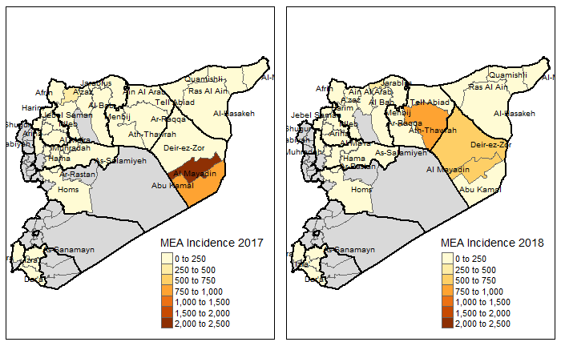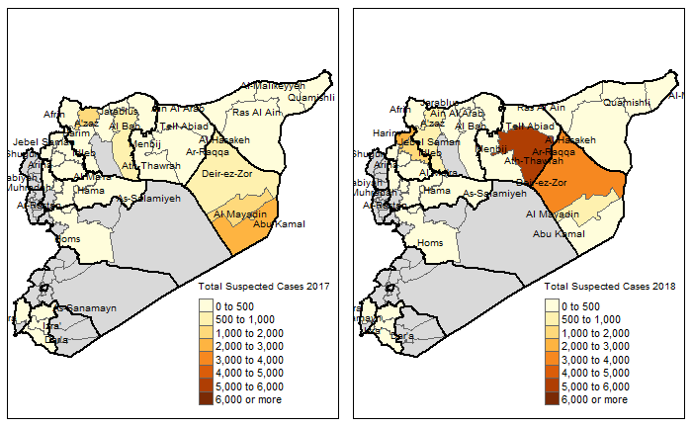

1. **Discussion**

This study examined incidence of measles between January 2015 and June 2019 through an active surveillance system program that has bee running in non-state territories in northern Syria. We found that measles, which had been eliminated in Syria since 1999, has seen a resurgence, with an epidemic in 2017 and another in 2018. 42

The outbreaks follow a mostly biannual outbreak trend. In 2017, the epidemic began in late March, with a rapid escalation to peak incidence levels just two months later, and gradual resolution by late October. The 2018 epidemic began much earlier, as early as November of 2017, and lasted nearly a year until the beginning of October of 2018. This second outbreak is likely a continuation of the first, largely affecting regions adjacent to those targeted by the first outbreak.

The measles outbreak in 2017 was largely confined three districts: *Abu Kamal* and *Al-Mayadin*, two neighboring districts in the east of the country in the *Deir-ez-Zor* Governorate, and a relatively minor outbreak in *A’zaz*, in the north of the Aleppo governorate. In 2018, the outbreak spread farther west, affecting the districts of *Al-Mayadin* and *Deir-ez-Zor* in the *Deir-ez-Zor* governorate and *Ath-Thawrah* in the *Ar-Raqqa* governorate, with another minor outbreak in *Jarablus* in the north of the Aleppo governorate. Districts with high incidence of measles in 2017 experienced a decrease in incidence the following year, and no outbreaks were reported in 2019, suggesting a reduction in the at-risk population due to acquired immunity and/or vaccination efforts.

There is also the unexpected finding of higher incidence amongst females ≥5 years old than males ≥5 years old. It may be that this is not reflective of a true difference of incidence in the population, but rather a difference due to barriers to accessing care for males, such as increased security risks for men, since men reported being targeted more by police and military forces at check-points and chance encounters. It may also reflect a true difference in incidence, perhaps due to females being able to commute more safely than males and thus have an increased number of contacts, or because males had greater access to vaccinations.

It is also interesting to note that 2017 was the first year in which the entire <5 year-old population was born during the conflict. While it is unclear exactly how this fact has influenced these two epidemics, it stands to reason that this segment of the population was especially vulnerable to changes in access to routine vaccinations.

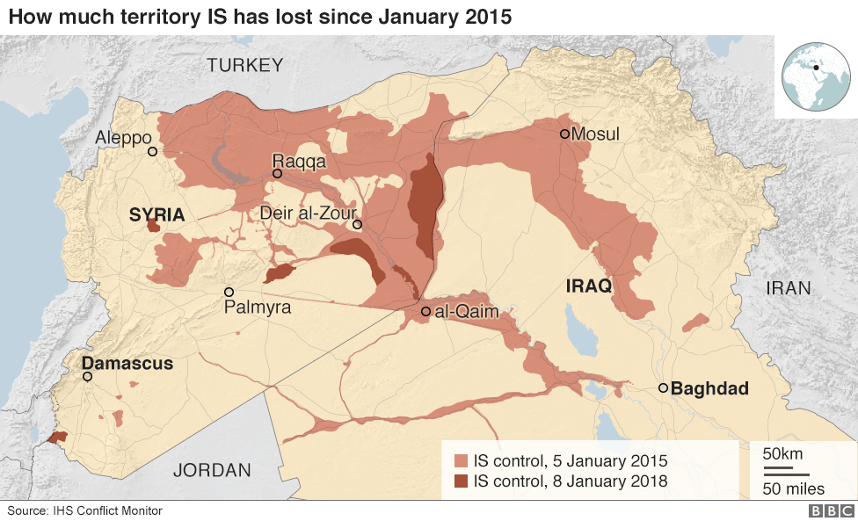The populated regions of *Ar-Raqqa* and *Deir-ez-Zor* fell to various opposition groups in the spring of 2013 and were primarily under *Daesh* control from January 2014 – August 2017. These areas were largely inaccessible to many aid organizations and ACU’s laboratory surveillance efforts were restricted, although Daesh did comply with the ACU’s polio campaigns in the areas and infectious disease reports were still able to make it through, albeit discretely. *Deir-ez-Zor* shares a border with Iraq, and was a gateway for many fighters to enter Syria during the early stages of the conflict. The 2013 polio outbreak occurred in *Deir-ez-Zor*, suggesting that routine vaccination and adequate sanitation had fallen even before then.

ACU’s EWARN has proven itself to be a robust surveillance system and is often the only source for infectious disease data from non-state territories.44 The data they have collected and distributed have helped guide clinical practice within Syria, inform vaccination and other intervention efforts of many NGOs, improve triaging of limited resources, facilitate the mobilization of support from donor organizations, and provide access to precious information to the international community in a timely fashion. Paradoxically, information on the spread of certain infectious diseases within the EWARN coverage regions may be more accessible now than ever before.

The system has remained stable despite the conflict, able to detect both the large annual surges of suspected typhoid fever cases in the fall and minute deviations from the baseline incidence of acute flaccid paralysis to trigger investigations for polio. By reporting the timeliness and completeness of each district’s reports and utilizing a zero-reporting protocol, gaps in surveillance data can be easily identified, and unreported information can be distinguished from the true absence of cases.

Limitations

There are several important limitations to consider for this study, given the context of conflict in which the data was collected.

First, we face methodological constraints. This study uses ecological data, and can only make associations at the population level. Population estimates in non-state territories were difficult to accurately assess, so we utilized UNOCHA data. However, UNOCHA used different methods between 2015-2016 than between 2017-2019 population estimates; population was measured at the district level between 2015-2016 and at the subdistrict level between 2017-2019, and it is unclear how this may have influenced population estimates.

We also faced practical limitations. We did not have access to data on weekly incidence rates for measles in Syria prior to the conflict or between the start of the conflict in March 2011 and when ACU began publishing their data in January 2015. Population in Syria has been dynamic throughout the course of the war, especially in areas most affected by health. This not only further complicates accurate population estimates to match with weekly disease reports, but it also raises the question whether changes in case counts within a given district are due to factors directly affecting that district or factors that impact neighboring districts. For example, if District A loses its only hospital, and people within District A have to travel to District B to seek care, we will see a change in incidence in District B even though this is because of access to care in District A.

Thus, while this study is not able to make causal inferences about the etiology of these outbreaks, we can conclude that these outbreaks did take place, that segments of the Syrian population have become vulnerable to vaccine-preventable diseases, and that it is possible to collect valuable, accurate, and reasonably consistent data in real-time during a conflict for response, advocacy, and research purposes.

Conclusion

The conflict in Syria has reduced routine healthcare services in non-state territories, leading to two major outbreaks of measles in 2017 and 2018. Although we cannot deduce which policies or actors were directly responsible for the two measles outbreaks, we can surmise that the regions affected the outbreaks were heavily targeted in the conflict, they were limited in their access to aid organizations or government services, and that these factors may have contributed to decreased vaccination rates and thus increased vulnerability to a measles epidemic. This study also highlights the efforts of dedicated healthcare professionals to rigorously document the spread of infectious diseases in the midst of conflict, and how powerful this kind of data is, not only for rapid response and advocacy, but for research as well. Vaccines and other routine healthcare services are a human right, whatever the circumstance, and efforts to document lapses in such services and the consequences of these lapses are an important step in preserving that right. Further studies relating the severity of the conflict, intra-conflict policies and tactics, or attacks on healthcare facilities should be conducted to better understand their impact on vaccine preventable diseases.

Conflict of Interest

No conflicts of interests to declare. This study was funded by the University of California, Berkeley Human Rights Center and the UCB-UCSF Joint Medical Program.

---------------------------------------

Appendix

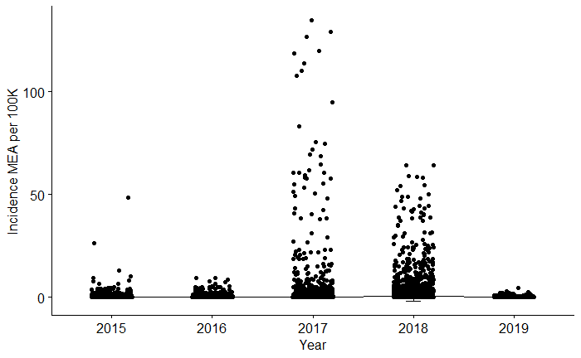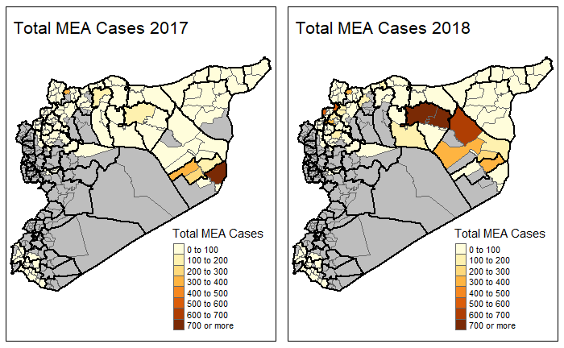

|  |  |  |  |  |  |
| --- | --- | --- | --- | --- | --- |
| Cases of Measles | <5 Male | <5 Female | >5 Male | >5 Female | Total Cases |
| Aleppo Total: | **1663** | **1512** | **1232** | **1045** | **5452** |
| Afrin | 25 | 48 | 127 | 96 | 296 |
| Ain Al Arab | 26 | 21 | 18 | 9 | 74 |
| Al Bab | 161 | 169 | 187 | 150 | 667 |
| A'zaz | 607 | 527 | 325 | 324 | 1783 |
| Jarablus | 146 | 147 | 89 | 109 | 491 |
| Jebel Saman | 255 | 217 | 169 | 134 | 775 |
| Menbij | 443 | 383 | 317 | 223 | 1366 |
| Al-Hasakeh Total: | **195** | **174** | **128** | **103** | **600** |
| Al-Hasakeh | 23 | 18 | 8 | 10 | 59 |
| Al-Malikeyyeh | 28 | 22 | 21 | 27 | 98 |
| Quamishli | 96 | 85 | 57 | 26 | 264 |
| Ras Al Ain | 48 | 49 | 42 | 40 | 179 |
| Ar-Raqqa Total: | **2226** | **2180** | **1937** | **1682** | **8025** |
| Ar-Raqqa | 1843 | 1820 | 1743 | 1537 | 6943 |
| Ath-Thawrah | 254 | 230 | 101 | 85 | 670 |
| Tell Abiad | 129 | 130 | 93 | 60 | 412 |
| Dar'a Total: | **85** | **114** | **35** | **33** | **267** |
| As-Sanamayn | 3 | 4 | 1 | 0 | 8 |
| Dar'a | 39 | 64 | 19 | 23 | 145 |
| Izra' | 43 | 46 | 15 | 10 | 114 |
| Deir-ez-Zor Total: | **2601** | **2608** | **1760** | **1336** | **8305** |
| Abu Kamal | 751 | 815 | 533 | 354 | 2453 |
| Al Mayadin | 658 | 765 | 446 | 288 | 2157 |
| Deir-ez-Zor | 1192 | 1028 | 781 | 694 | 3695 |
| Hama Total: | **28** | **31** | **21** | **10** | **90** |
| As-Salamiyeh | 8 | 3 | 3 | 2 | 16 |
| As-Suqaylabiyah | 7 | 16 | 14 | 7 | 44 |
| Hama | 9 | 10 | 4 | 1 | 24 |
| Muhradah | 4 | 2 | 0 | 0 | 6 |
| Homs Total: | **0** | **0** | **1** | **0** | **1** |
| Ar-Rastan | 0 | 0 | 1 | 0 | 1 |
| Homs | 0 | 0 | 0 | 0 | 0 |
| Idleb Total: | **1745** | **1478** | **876** | **818** | **4917** |
| Al Ma'ra | 128 | 117 | 66 | 55 | 366 |
| Ariha | 92 | 74 | 24 | 34 | 224 |
| Harim | 757 | 647 | 390 | 379 | 2173 |
| Idleb | 595 | 481 | 324 | 264 | 1664 |
| Jisr-Ash-Shugur | 173 | 159 | 72 | 86 | 490 |
| Quneitra Total: | **5** | **15** | **17** | **13** | **50** |
| Quneitra | 5 | 15 | 17 | 13 | 50 |
| *Grand Total:* | **8,548** | **8,112** | **6,007** | **5,040** | **27,707** |

Extra:

TMI on Hx:

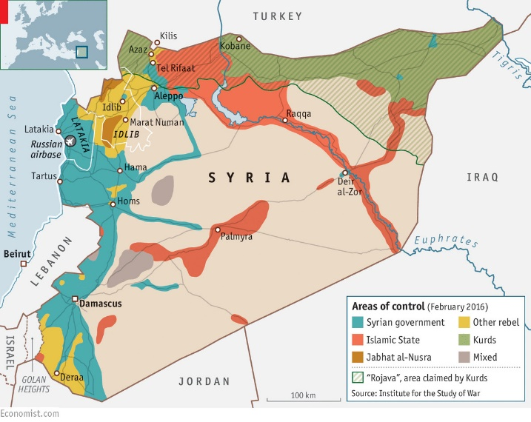March 4, 2013, the governorate of Ar-Raqqa fell to the Syrian opposition, with several groups, including Al-Nusra Front and what was then known as the Islamic State in Iraq (ISI) operating there. ISI attempted to merge with Al-Nusra front in April 2013, and changed its name to the Islamic State in Iraq and Syria (ISIS), known in Arabic as *Daesh*, but the latter rejected, allying themselves with Al-Qaeda instead. In January of 2014, *Daesh* takes over Ar-Raqqa and declares it as its new capital. In June of that year, *Daesh* seizes the border between Iraq and Deir-ez-Zor. By 2015, *Daesh* had reached its maximum extent, with control of the governorates of Deir-ez-Zor and Ar-Raqqa, and parts of Homs, Hama, and Al-Hasekeh, and eastern Aleppo.

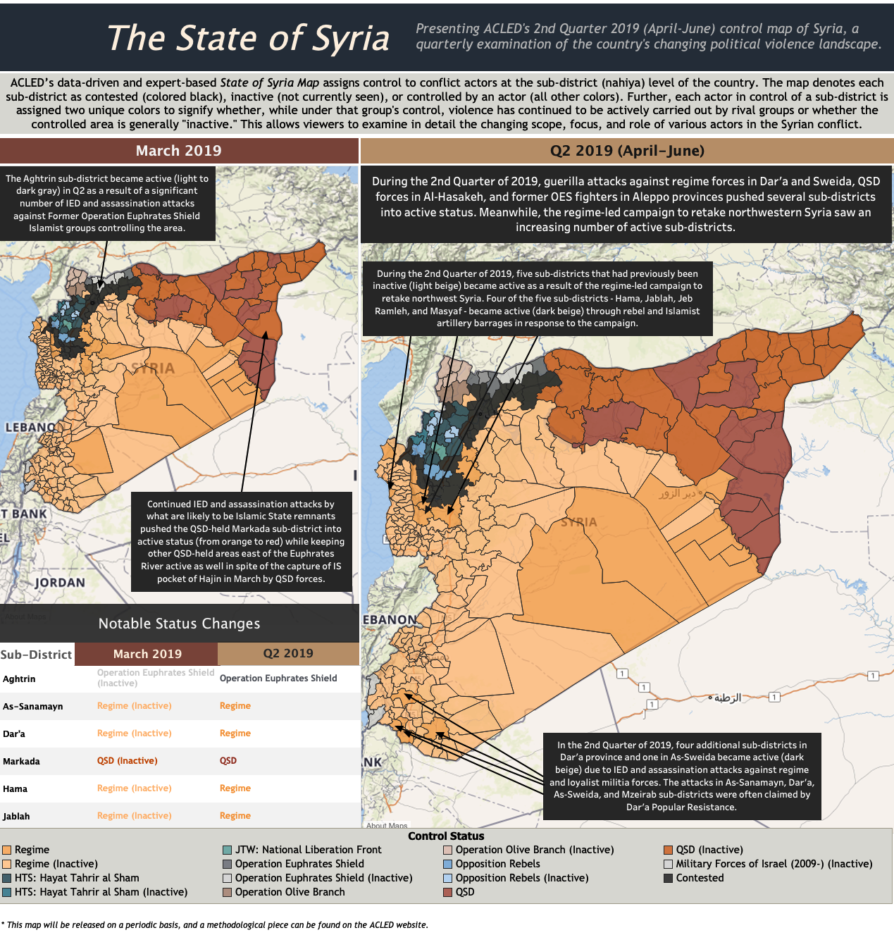

1. **References**

1. Levy BS, Sidel VW. *War and Public Health*.; 2009. doi:10.1093/acprof:oso/9780195311181.001.0001

2. Levy BS, Sidel V. Documenting the Effects of Armed Conflict on Population Health. *Ssrn*. 2016. doi:10.1146/annurev-publhealth-032315-021913

3. Sahloul MZ, Monla-Hassan J, Sankari A, et al. War is the enemy of health pulmonary, critical care, and sleep medicine in war-torn Syria. *Ann Am Thorac Soc*. 2016;13(2):147-155. doi:10.1513/AnnalsATS.201510-661PS

4. Rubenstein LS, Bittle MD. Responsibility for protection of medical workers and facilities in armed conflict. *Lancet*. 2010;375(9711):329-340. doi:10.1016/S0140-6736(09)61926-7

5. Haar RJ, Risko CB, Singh S, et al. Determining the scope of attacks on health in four governorates of Syria in 2016: Results of a field surveillance program. *PLoS Med*. 2018;15(4):1-18. doi:10.1371/journal.pmed.1002559

6. Agency CI. The World Factbook: Syria. The World Factbook. https://www.cia.gov/library/publications/the-world-factbook/geos/sy.html. Published 2019.

7. UNHCR. Situation in Syria Regional Refugee Response. 15 August 2019. https://data2.unhcr.org/en/situations/syria. Published 2019.

8. Specia M. How Syria’s Death Toll Is Lost in the Fog of War. *New York Times*. https://www.nytimes.com/2018/04/13/world/middleeast/syria-death-toll.html. Published April 13, 2018.

9. Rossi R, Assaad R, Rebeschini A, Hamadeh R. Vaccination coverage cluster surveys in middle Dreib - Akkar, Lebanon: Comparison of vaccination coverage in children aged 12-59 months Pre-and post-vaccination campaign. *PLoS One*. 2016;11(12). doi:10.1371/journal.pone.0168145

10. DeJong J, Ghattas H, Bashour H, Mourtada R, Akik C, Reese-Masterson A. Reproductive, maternal, neonatal and child health in conflict: a case study on Syria using Countdown indicators. *BMJ Glob Heal*. 2017;2(3):e000302. doi:10.1136/bmjgh-2017-000302

11. Sharara SL, Kanj SS. War and infectious diseases: challenges of the Syrian civil war. *PLoS Pathog*. 2014;10(10):e1004438. doi:10.1371/journal.ppat.1004438

12. Meiqari L, Hoetjes M, Baxter L, Lenglet A. Impact of war on child health in northern Syria: the experience of Médecins Sans Frontières. *Eur J Pediatr*. 2018;177(3):371-380. doi:10.1007/s00431-017-3057-y

13. Taub B. The Shadow Doctors. *New Yorker*. June 2016:21. https://www.newyorker.com/magazine/2016/06/27/syrias-war-on-doctors.

14. Sen K, Al-Faisal W, Alsaleh Y. Syria: Effects of conflict and sanctions on public health. *J Public Heal (United Kingdom)*. 2013;35(2):195-199. doi:10.1093/pubmed/fds090

15. Fouad FM, Sparrow A, Tarakji A, et al. Health workers and the weaponisation of health care in Syria: a preliminary inquiry for The Lancet–American University of Beirut Commission on Syria. *Lancet*. 2017;390(10111):2516-2526. doi:10.1016/S0140-6736(17)30741-9

16. PHR. Aleppo Abandoned: A Case Study on Health Care in Syria. 2015;(November). https://s3.amazonaws.com/PHR_Reports/aleppo-abandoned.pdf.

17. WHO. *Emergencies Preparedness, Response: Polio in the Syrian Arab Republic*.; 2013. https://www.who.int/csr/don/2013_10_29/en/.

18. Sparrow A. Syria ’ s Assault on Doctors. 2013:1-7.

19. Nnadi C, Etsano A, Uba B, et al. HHS Public Access. 2018;216(Suppl 1):1-10. doi:10.1093/infdis/jix175.Approaches

20. Close RM, Pearson C, Cohn J. Vaccine-preventable disease and the under-utilization of immunizations in complex humanitarian emergencies. *Vaccine*. 2016;34(39):4649-4655. doi:10.1016/j.vaccine.2016.08.025

21. Caplan AL, Curry DR. Refugees, humanitarian aid and the right to decline vaccinations. *J Med Ethics*. 2015;41(3):276-277. doi:10.1136/medethics-2014-102383

22. Lam E, McCarthy A, Brennan M. Vaccine-preventable diseases in humanitarian emergencies among refugee and internally- displaced populations. *Hum Vaccin Immunother*. 2017;11(11):2627-2636. doi:10.1080/21645515.2015.1096457

23. Stone-Brown K. Syria: A healthcare system on the brink of collapse. *BMJ*. 2013;347(December):1-3. doi:10.1136/bmj.f7375

24. WHO. Surveillance teams risk all to track disease outbreaks in northern Syria. April 2018. http://www.euro.who.int/en/health-topics/emergencies/pages/news/news/2018/4/surveillance-teams-risk-all-to-track-disease-outbreaks-in-northern-syria. Accessed September 14, 2019.

25. Ismail SA, Abbara A, Collin SM, et al. Communicable disease surveillance and control in the context of conflict and mass displacement in Syria. *Int J Infect Dis*. 2016;47:15-22. doi:10.1016/j.ijid.2016.05.011

26. Ozaras R, Leblebicioglu H, Sunbul M, et al. The Syrian conflict and infectious diseases. *Expert Rev Anti Infect Ther*. 2016;14(6):547-555. doi:10.1080/14787210.2016.1177457

27. Ahmad B, Bhattacharya S. Polio eradication in Syria. *Lancet Infect Dis*. 2014;14(7):547-548. doi:10.1016/S1473-3099(14)70803-5

28. ACU. Assistance Coordination Unit: Identity. https://www.acu-sy.org/en/identity/. Published 2019. Accessed August 20, 2019.

29. Kennedy J, Michailidou D. Civil war, contested sovereignty and the limits of global health partnerships: A case study of the Syrian polio outbreak in 2013. *Health Policy Plan*. 2017;32(5):690-698. doi:10.1093/heapol/czw148

30. ACU. *EWARN Guidelines*. Gaziantep, Turkey; 2017. https://www.acu-sy.org/en/guidelines-ewarn-guidelines/.

31. Taleb Z Ben, Bahelah R, Fouad FM, Wilcox ML. Syria : Health in a country Undergoing Tragic Transition Syria. *Int J Public Health*. 2014;(July). doi:10.1007/s00038-014-0586-2

32. L. M, M. H, L. B. Impact of war on child health in northern Syria: the experience of Medecins Sans Frontieres. *Eur J Pediatr*. 2018;177(3):371-380. doi:http://dx.doi.org/10.1007/s00431-017-3057-y

33. Lam E, Diaz M, Maina AGK, Brennan M. Displaced populations due to humanitarian emergencies and its impact on global eradication and elimination of vaccine-preventable diseases. *Confl Health*. 2016;10(1):5-7. doi:10.1186/s13031-016-0094-5

34. Syrian Arab Republic, WHO. WHO: Early Warning and Response System in Syria. http://www.emro.who.int/syr/publications-other/ewars-weekly-bulletin.html. Published 2019.

35. CDC. Help and Hope for Syrian Refugees: The Many Ways We Take Action in a Crisis. Division of Global Health Protection. https://www.cdc.gov/globalhealth/healthprotection/fieldupdates/summer-2016/syrian-crisis-timeline.html. Accessed September 14, 2019.

36. UNOCHA. UN Office for the Coordination of Humanitarian Affairs: Syrian Arab Republic. https://www.unocha.org/syrian-arab-republic/about-ocha-syria. Published 2019.

37. WHO, UNICEF. *Overview of Vaccine Preventable Diseases Surveillance Principles*. Geneva, Switzerland; 2018. doi:10.1071/NB03028

38. Moss WJ. Measles. *Lancet (London, England)*. 2017;390(10111):2490-2502. doi:10.1016/S0140-6736(17)31463-0

39. Bennett J, Dolin R, Blaser MJ. *Mandell, Douglas, and Bennett’s Principles and Practice of Infectious Diseases*. 8th ed. Saunders; 2015.

40. WHO. Measles: Immunization , Vaccines and Biologicals Measles. https://www.who.int/immunization/monitoring_surveillance/burden/vpd/surveillance_type/active/measles/en/. Published 2018.

41. WHO. WHO: New measles surveillance data from WHO. *WHO*. 2019. https://www.who.int/immunization/newsroom/new-measles-data-august-2019/en/. Accessed September 14, 2019.

42. WHO. *WHO Vaccine-Preventable Diseases Country Profile: Syrian Arab Republic*. World Health Organization https://apps.who.int/immunization_monitoring/globalsummary/incidences?c=SYR. Accessed September 19, 2019.

43. Durrheim DN, Crowcroft NS, Strebel PM. Measles – The epidemiology of elimination. *Vaccine*. 2014;32(51):6880-6883. doi:10.1016/j.vaccine.2014.10.061

44. CDC. CDC Global Health - Infographics - Early Warning Alert And Response Network Put The Brakes On Deadly Diseases. https://www.cdc.gov/globalhealth/infographics/global-health-security/ewarn.htm. Accessed September 14, 2019.